Modelo bayesian hypertuner

comienza 2024-02-13 19:11:41

paro en 2024-02-13 22:05:25

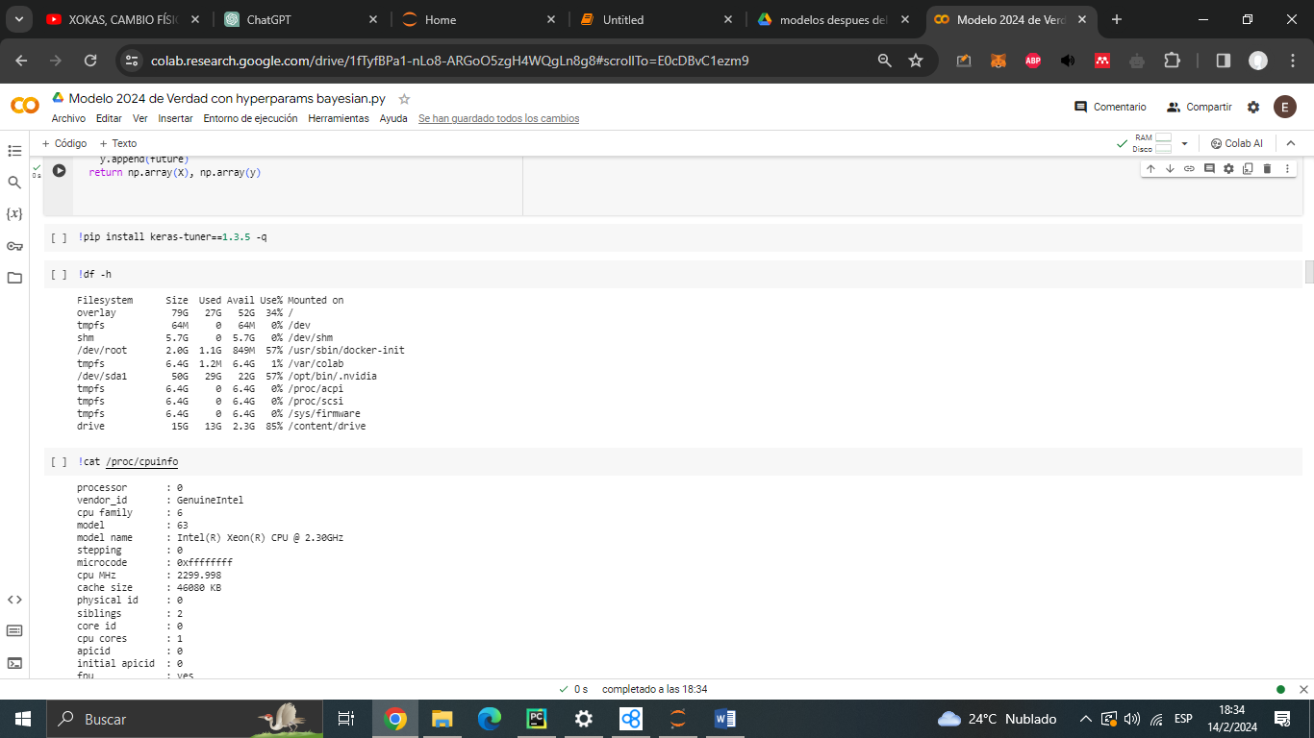

!cat /proc/cpuinfo

processor : 0

vendor_id : GenuineIntel

cpu family : 6

model : 63

model name : Intel(R) Xeon(R) CPU @ 2.30GHz

stepping : 0

microcode : 0xffffffff

cpu MHz : 2299.998

cache size : 46080 KB

physical id : 0

siblings : 2

core id : 0

cpu cores : 1

apicid : 0

initial apicid : 0

fpu : yes

fpu_exception : yes

cpuid level : 13

wp : yes

flags : fpu vme de pse tsc msr pae mce cx8 apic sep mtrr pge mca cmov pat pse36 clflush mmx fxsr sse sse2 ss ht syscall nx pdpe1gb rdtscp lm constant_tsc rep_good nopl xtopology nonstop_tsc cpuid tsc_known_freq pni pclmulqdq ssse3 fma cx16 pcid sse4_1 sse4_2 x2apic movbe popcnt aes xsave avx f16c rdrand hypervisor lahf_lm abm invpcid_single ssbd ibrs ibpb stibp fsgsbase tsc_adjust bmi1 avx2 smep bmi2 erms invpcid xsaveopt arat md_clear arch_capabilities

bugs : cpu_meltdown spectre_v1 spectre_v2 spec_store_bypass l1tf mds swapgs mmio_stale_data retbleed

bogomips : 4599.99

clflush size : 64

cache_alignment : 64

address sizes : 46 bits physical, 48 bits virtual

power management:

processor : 1

vendor_id : GenuineIntel

cpu family : 6

model : 63

model name : Intel(R) Xeon(R) CPU @ 2.30GHz

stepping : 0

microcode : 0xffffffff

cpu MHz : 2299.998

cache size : 46080 KB

physical id : 0

siblings : 2

core id : 0

cpu cores : 1

apicid : 1

initial apicid : 1

fpu : yes

fpu_exception : yes

cpuid level : 13

wp : yes

flags : fpu vme de pse tsc msr pae mce cx8 apic sep mtrr pge mca cmov pat pse36 clflush mmx fxsr sse sse2 ss ht syscall nx pdpe1gb rdtscp lm constant_tsc rep_good nopl xtopology nonstop_tsc cpuid tsc_known_freq pni pclmulqdq ssse3 fma cx16 pcid sse4_1 sse4_2 x2apic movbe popcnt aes xsave avx f16c rdrand hypervisor lahf_lm abm invpcid_single ssbd ibrs ibpb stibp fsgsbase tsc_adjust bmi1 avx2 smep bmi2 erms invpcid xsaveopt arat md_clear arch_capabilities

bugs : cpu_meltdown spectre_v1 spectre_v2 spec_store_bypass l1tf mds swapgs mmio_stale_data retbleed

bogomips : 4599.99

clflush size : 64

cache_alignment : 64

address sizes : 46 bits physical, 48 bits virtual

power management:

!cat /proc/meminfo

MemTotal: 13290480 kB

MemFree: 9345020 kB

MemAvailable: 11965080 kB

Buffers: 80724 kB

Cached: 2737236 kB

SwapCached: 0 kB

Active: 857452 kB

Inactive: 2817912 kB

Active(anon): 1632 kB

Inactive(anon): 858236 kB

Active(file): 855820 kB

Inactive(file): 1959676 kB

Unevictable: 16 kB

Mlocked: 16 kB

SwapTotal: 0 kB

SwapFree: 0 kB

Dirty: 2704 kB

Writeback: 0 kB

AnonPages: 855500 kB

Mapped: 642800 kB

Shmem: 2456 kB

KReclaimable: 91004 kB

Slab: 131768 kB

SReclaimable: 91004 kB

SUnreclaim: 40764 kB

KernelStack: 5552 kB

PageTables: 13824 kB

SecPageTables: 0 kB

NFS_Unstable: 0 kB

Bounce: 0 kB

WritebackTmp: 0 kB

CommitLimit: 6645240 kB

Committed_AS: 2878076 kB

VmallocTotal: 34359738367 kB

VmallocUsed: 75916 kB

VmallocChunk: 0 kB

Percpu: 1088 kB

HardwareCorrupted: 0 kB

AnonHugePages: 0 kB

ShmemHugePages: 0 kB

ShmemPmdMapped: 0 kB

FileHugePages: 0 kB

FilePmdMapped: 0 kB

CmaTotal: 0 kB

CmaFree: 0 kB

Unaccepted: 0 kB

HugePages_Total: 0

HugePages_Free: 0

HugePages_Rsvd: 0

HugePages_Surp: 0

Hugepagesize: 2048 kB

Hugetlb: 0 kB

DirectMap4k: 160568 kB

DirectMap2M: 4030464 kB

DirectMap1G: 11534336 kB

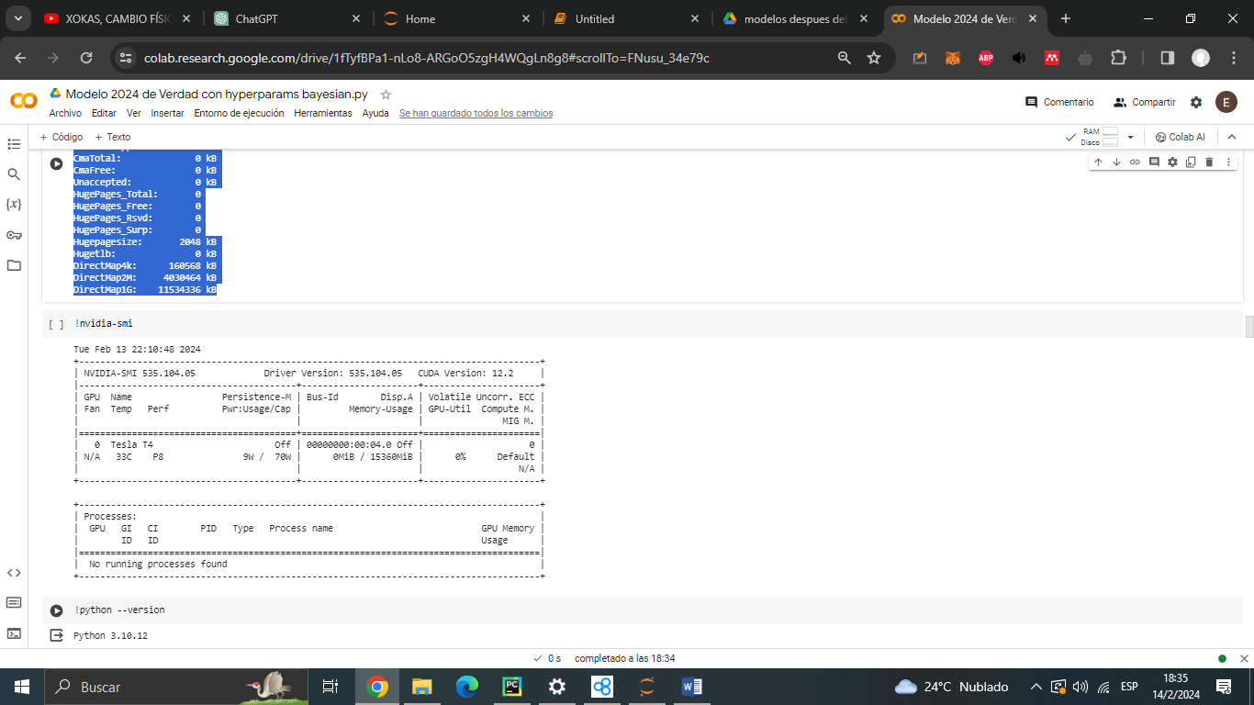

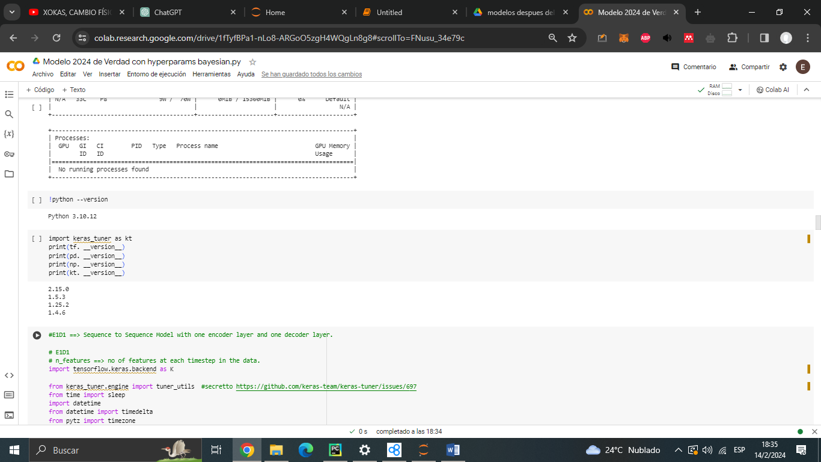

Segunda Pasada

Comienza 2024-02-14 18:36:37

2024-02-14 20:06:27